**LAB 01**

**Before Understanding of Business and not Taking Requirements**

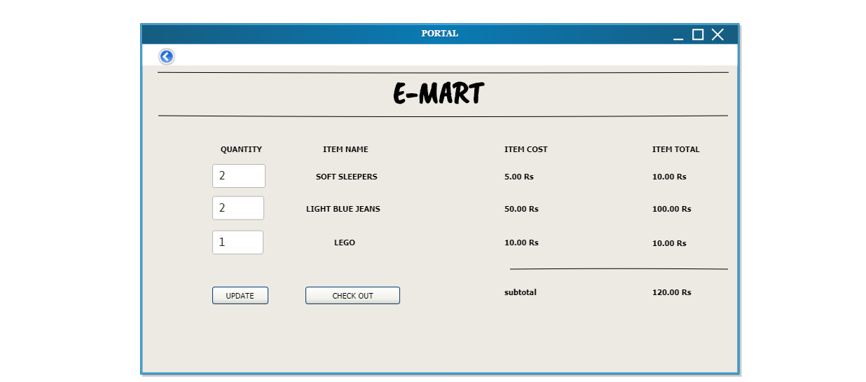

**After Taking Requirements and Understanding Business**

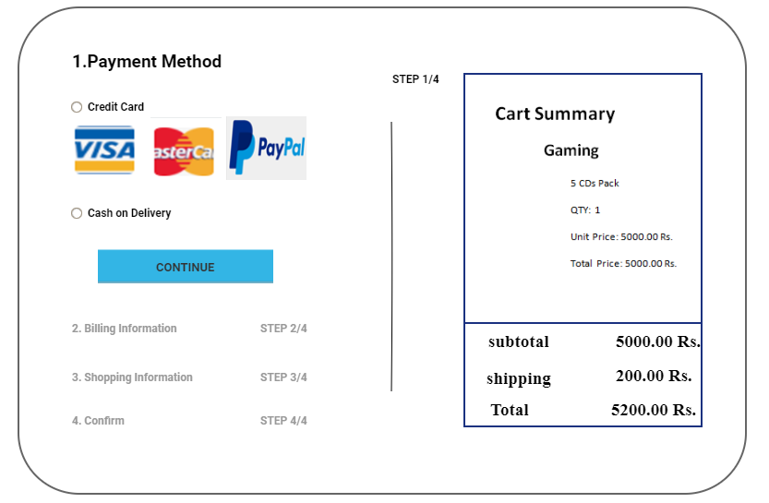

# Student Task:

Considering your project as a sample, design user interface screens.

You are required to design TWO interaction screens, one without knowing the principles and one after understanding the principles. The second version should clearly indicate usage of the principles.

The conclusion should include answers of the questions:

1. Explain the importance of good design and benefits of good design?
2. What are the steps involved in designing a Good User Interface?

**Answers:**

1. Explain the importance of good design and benefits of good design?

**Importance of a Good Designs is:**

A well designed interfaces and presentation on screen is important to the users because that’s the screen for them to view the capabilities of the system. It is the way through which many critical tasks or function are presented and solved, to make a system user friendly which has a direct impact on the organizations relation with the customers.

**Benefits of a good design are:**

1. Screens are relatable easy to use to understand payment method
2. Would be less time consuming to make transaction of your choice
3. Operations are easy to perform
4. Screen would be more productive
5. Error less environment transaction is clear in sense of everything is smooth
6. Each step is clearly defined what to do
7. Training cost are lower
8. The organization customers benefit because of improved services
9. Graphics are good and colors are attractive and attract people to easily use
10. Easily understandable by teenagers and above age group
11. If logic is according to business logic is really both good for company and customer
12. Easily readable

2. What are the steps involved in designing a Good User Interface?

Interface elements include:

* **Input Controls**: buttons, text fields, checkboxes, radio buttons, dropdown lists, list boxes, toggles, date field
* **Navigational Components**:

Slider, search field, pagination, slider, tags, icons etc.

* **Informational Components**:

Icons, progress bar, notifications, message boxes etc.

* **Keep the interface simple.**

The best interfaces are almost invisible to the user. They avoid unnecessary elements and language is clear they use on labels and in messaging.

* **Create consistency and use common UI elements.**

 By using [common elements](https://www.usability.gov/how-to-and-tools/methods/user-interface-elements.html) in your UI, users feel more comfortable and are able to get things done more quickly.  It is also important to create patterns in language, layout and design throughout the site to help facilitate efficiency.

* **Be purposeful in page layout.**

Careful placement of items can help draw attention to the most important pieces of information and can aid scanning and readability, color, texture etc.

* **Use typography to create hierarchy and clarity.** Carefully consider how you use typeface. Different sizes, fonts, and arrangement of the text to help increase scanability, legibility and readability.
* **Make sure that the system communicates what’s happening.**

Always inform your users of location, actions, changes in state, or errors. The use of various UI elements to communicate status and, if necessary, next steps can reduce frustration for your user.

* **Think about the defaults.**

You can create defaults that reduce the burden on the user.  This becomes particularly important when it comes to form design where you might have an opportunity to have some fields pre-chosen or filled out.